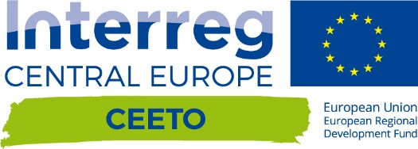

CEETO

CEETO Deliverable D.T2.2.1  Establishment or renovation of a participatory planning system in each PA | Version 1.0  11 2018

Introduction
Within the deliverable DT2.2.1 each pilot area has to establish or renovate a participatory planning system in each PA which ment the formal establishment (if not yet existing) or renovation (if already existing) of a consulting body (e.g. the ECST Forum) involving the main stakeholders dealing with tourism in each PA. Each document includes a list of the participating stakeholders.
Po Delta Regional Park started from the very first step to set up a participatory planning system because it was never established a round table with the involvement of local stakeholders in themes concerning the Park such as tourism.
For this reason a collaboration with the local public administration has begun, inviting all the stakeholders which are, from different point, in contact with tourists in order to involve and convince them to bring their knowledge of the “tourism phenomenon” to start working on. This list is composed of hotel, restaurants, tourist offices, visitor centres of the Park, etc.

Stakeholder list
Organisation | Type
AQUA SRL | Private enterprise
Architetto | Private enterprise
Argenta Tourist Information Office | Tourist information office
Ascom Confesercenti Cervia | Commerce trade association
Associazione culturale studiod'archeologia didattica museologia | Private association
Associazione Festa | Private association
Assohotel Cervia | Hotel association
Atlantide soc. coop.sociale p.a. | Private enterprise
B&B Penelope Mesola | Private enterprise
Birding Italy | Private association
C.A.D.F. S.p.A | Private enterprise
CNA Cervia | Commerce trade association
Confartigianato | Commerce trade association
Consorzio Visit Ferrara | Private enterprise
COPEGO | Cooperativa
DELTA 2000 | Local Action Group
Erbe Palustri Ecomuseum | Private association
Fattorie del Delta/ Pro Loco di Mesola | Private enterprise
FederParchi | Federparchi
Hotel Eros Residence | Private enterprise
Il Bosco Officinale | Private enterprise
Istituto Comprensivo Codigoro - | School
Locanda degli este | Private enterprise
Municipality of Cervia | Local Public Administration
Municipality of Comacchio | Local Public Administration
Municipality of Mesola | Local Public Administration
Municipality of Ravenna | Local Public Administration
Nautica Mondo | Private enterprise
Oasi Canneviè | Private enterprise
Ostello bar Gorino | Private enterprise
Porto Tolle Tourist Information Office | Tourist information office
Pro Loco Codigoro | Local association
Simpatia srl | Private enterprise
Spiaggia Romea srl | Private enterprise
Tourist Service Municipality of Goro | Tourist information office
Urban planner | Private enterprise
WWF Ravenna Association | NGO

