CEETO – Appennino Tosco-Emiliano national park

D.T2.2.3- Strategy and Action Plan | Version 1.0  11 2018

- Protected Area Description
The Appennino Tosco-Emiliano National Park was founded in 2001.
Its area measureas 26.149 hectares, the majority of them in Emilia Romagna Region, and it includes 4 provinces: Lucca and Massa Carrara in Tuscany Region, Parma and Reggio Emilia in Emilia Romagna Region, for a total of 13 Municipalities.
Inside the Park’s boundaries there are also 4 National Natural Reserves: Orecchiella, Lamarossa, Pania di Corfino in the province of Lucca, and Guadine Pradaccio in the province of Parma.
The National Park is placed in a very specific geographical area and its boundaries were defined according to a specific strategy of safeguard and promotion of sustainable development because of the recognition of the the same natural and ecosystem features in this part of the Apennines.
The climatic border between the European and continental climate in the northern side of the Park (Emilia – Romagna) meets the Mediterranean climate of the Southern slope of the Apennine (Tuscany) on the ridge of the Apennine, defining natural habitats and ecosystems but also the human presence, activities and culture.
Mountain peaks have an average altitude of 1600 meters above sea level, with a few major peaks reaching 1900-2100 meters. The highest peak in the region is Mount Cusna 2120 meters, followed by Mount Prado 2054 meters and Alpe di Succiso 2017 meters. At that altitude there are no longer trees - you only can see rocks and grasslands, where sheep have grazed for hundreds of years, and striking views of the Apennines, the Apuan Alps and, in clear days, the alps on the north and the sea on the south views.
There is an incredible variety of different natural environments and habitats, such as hills and mountains, prairies and moorlands, forests, high peaks, lakes. There are also traces of old and traditional human activities (metati, mills, farmers houses).
The 97,6% of the territory of the Park is characterized by forest such as beeches, chestnuts and oaks while the 17,8 % is made by pastures and prairies. A less quantity of the area is characterized by conifers and shrubs.
Other important species are the white fir trees, junipers, primroses, primula appenninica, daffodils, blueberries and mushrooms
The macro fauna is characterized by these species: wolf, golden eagle, bats, spectacled salamander, peregrine falcon, common krestel, common buzzard, owl, red deers and roe deers, wild boar, fox, hedgehog, brown trout Italian barbel, Mediterranean barbell, hermit beetle, rosalia longicorn.
Some of the most important geological sites are the Pietra di Bismantova and the Triassic chalks in the northern side of the Park and the Pania di Corfino and Sassorosso in Garfagnana (Tuscan side of the Park).
Inside the Park area there are 7 sites SIC-ZPS, 8 SIC and 1 ZPS. The total area of these sites is 19.874 hectares, corresponding to the 76% of the Park.

Tipologia | Codice | Denominazione
Emilia-Romagna Region
S.I.C.-Z.P.S | IT4020020 | Crinale dell’Appennino pamense
S.I.C.-Z.P.S. | IT4030001 | Monte Acuto, Alpe di Succiso
S.I.C.-Z.P.S. | IT4030002 | Monte Ventasso
S.I.C.-Z.P.S. | IT4030003 | Monte La Nuda, Cima Belfiore, Passo del Cerreto
S.I.C.-Z.P.S. | IT4030004 | Val d'Ozola, Monte Cusna
S.I.C.-Z.P.S. | IT4030005 | Abetina Reale, Alta Val Dolo
S.I.C.-Z.P.S. | IT4030006 | Monte Prado
S.I.C. | IT4030008 | Pietra di Bismantova
S.I.C. | IT4030009 | Gessi Triassici
Tuscany Region
S.I.C. | IT5110002 | Monte Orsaro
S.I.C. | IT5110003 | Monte Matto-Monte Malpasso
S.I.C. | IT5110004 | Monte Acuto-Groppo di Camporaghena
S.I.C. | IT5110005 | Monte La Nuda – Monte Tondo
S.I.C. | IT5120002 | Monte Castellino – Le Forbici
S.I.C. | IT5120003 | Parco Orecchiella-Pania di Corfino-Lamarossa
S.I.C. | IT5120004 | Pania di Corfino
List of SIC and ZPS inside the Tosco Emiliano National Park.

- Introduction to the Strategy
It’s well known that tourism is one of the main economic sectors able to create positive effects, both direct and indirect, on local communities.
In a territory characterized by a strong culture and territorial traditions, tourism can support positively the development, enhancing and relaunching the traditional activities and businesses and at the same time maintaining a balanced demographic arrangement of local communities.
On the other side tourism can became a threat, when it suddenly and severely upsets the local way of living and running businesses, changing the use of the natural and cultural resources and threatening their conservation.
To avoid this, it is necessary to find the rights policies and share them with the local stakeholders to define a common model of touristic development sustainable for the environment and the traditional culture. According to this model the citizens are involved in the decision process, in the management of the touristic businesses and they reap the socio–economic benefits of tourism.
Since the beginning the National Park has been in touch, discussing and creating partnerships, with the local stakeholders. It is working on a specific strategy to establish a touristic culture based on the local features of the area and able to catch the new requests of a market always looking ahead.
In this context in 2014 the National Park was awarded the European Charter for Sustainable Tourism (ECST): it was interpreted as a tool for the cooperation with the local communities and as a general framework to coordinate all the other activities and make them more effective.
Also the subscription to the CEETO InterregCE project can be included in this vision and mission because it is strictly connected with the ECST goals and it strengthens the same messages.

- The Strategy
Tourism represents the most innovative chance for the National Park for a social and economic development. In fact, in the past tourism was not one of the primary factors of economic development on this area and it was only a “seasonal” resource (for example in summer or winter time).
This part of the Apennine was characterized and seen as an holiday resort for a long stay in summer (mainly elderly people rented here flats for 2 or 3 months from June to August to escape the hot temperatures of the cities). When this phenomenon disappeared, we remained with the “roots tourism”: emigrants came back home in the Apennine for holidays. But even this was not sufficiently exploited to create a concrete tourism. The ski tourism is also suffering the lack of snow and people.
It is clear that this area is not naturally devoted to tourism. The aim of the Park is to create a sustainable and multi- seasonal tourism district renovating these old models and building partnerships with the local stakeholders who are ready for this new step.
For the Park area this means also a “cultural” change: tourism has to be seen as an important chance for a social and economic development because it is a new and “young” resource if compared with the agricultural and pastoral resources that historically characterized this territory.
So, the idea is to “use” the richness of the National Park in terms of nature, history, culture, food and local products and gastronomy to make the Apennine more attractive for different kind of tourists in different periods and seasons of the year.
The local touristic enterprises should exploit this richness to create a complete offer and touristic packages. Unfortunately, at the moment they prefer to work by themselves without any connection/relationships with other local stakeholders.
That’s why this strategy can be useful to create new opportunities for the stakeholders to meet each others and in this way to create a complete and multi – seasonal offer also for new kinds of tourists and tourisms such as horse riding, hiking, gastronomy and local products, bikes and so on.
The process of involvement of the stakeholders in the creation of the strategy and of the Action Plan was born tank to a close relationship between the National Park and the local stakeholders.
The strategy of the Park wants to strengthen some touristic sectors that are interesting for this area such as bikes, horse riding, hiking (thanks to a good network of paths – for example the Alta Via dei Parchi).
The snow tourism must be changed: the ski lifts areas are no more the main attraction, especially if compared with others in other part of the Apennines (not only in the Alps). That’s way they still can be one of the many offers of the territory together with Nordic walking and snow shoes.
Another good point is to give value to the typical characteristics sharing some best practices as the community cooperatives (cooperative di comunità) which are strongly connected with this area (experiences of the villages of Cerreto Alpi and Succiso).
At the same time, it is good to enlarge the perspective and create relationships and partnerships outside the boundaries of the protected area for example thanks to projects like CEETO or the ECST.
To achieve this goal the Park created a communication plan: for each meeting many written invitations were sent by e-mail to the stakeholders mailing lists, they were published on the official website of the National Park (www.parcoappennino.it) and on the official Facebook pages of the Park and of the Unesco Man and Biosphere Reserve.
To become a Unesco MaB Reserve has been useful to pay attention to sustainable tourism and to a more general sustainable development and relationship between man and nature. The perspective used to face these themes is that this area will be a laboratory for sustainable development, being at the same time guarantee of safeguarding the ecosystems and driving force for the development of local communities. These 2 functions are strictly connected because the conservation can be really successful only with the involvement and support of local citizens and on the other side local communities can have a new chance of economic and social renewal through the understanding and enhancement of the peculiarities of their own area and territory.
The ECST will be soon renewed, always according to improve the stakeholders’ engagement sharing agreed objectives and actions such as a sustainable environmental impact, the visitors satisfaction, the economic performance, the local prosperity and quality of life. This through a regular monitoring and reporting of progress and results in the same way as for the ECST renewal.
In the next 5/10 years all these ideas and actions will be shared thanks to public meetings, events and assemblies: the methodology used will change according to the kind of event/meeting, even if the main method used for the thematic/focused meetings is the same used for the workshop on the spot of the CEETO project.
The projects will be developed and/or created according to the objectives and items we want to communicate, such as “UPVIVIUM - Biosfera Gastronomica a Km0” to enhance local products and gastronomy, LIFE M.I.R.C.O, LIFE EREMITA, “Geodiversità” e “Geosfera d’Appennino”, “Neve Natura e Cultura d’Appennino”.
The methodology used to manage the meetings was derived from the European Awareness Scenario Workshop, also known by the acronym EASW, an approach that allows an open discussion in order to identify solutions that are concrete and easy to implement.
After a brief presentation of the project, the participants have been asked to tell their vision of the future of the pilot area, expressing a forecast both on desired positive aspects (what I hope that will happen …) and on possible negative changes (what I fear that will happen …). A synthesis of the visions allowed, therefore, to identify the common transversal aspects in order to define a common vision of development of the sustainable tourism in the pilot areas.
During the second part of the workshop the Park has presented its pilot action - to be implemented in the area within the CEETO project - and the participants have been asked to make suggestions and additions to this proposal.
The workshops have been held in two consecutive days, 12th July 2018 for the area of Pietra di Bismantova and 13th July for the other pilot area, namely Piana di Lagdei. Both moments have been structured as follows:
- Presentation of the CEETO Project;
- The Pilot Area and its critical areas;
- Participated Activity - FUTURE SEARCH (Imagine the tourism you would like … Vision activities about the future of tourism in the pilot area);
- Presentation of the Pilot Action proposal and the Monitoring Plan;
- Participated Activity - IDEAS FACTORY (How can I contribute? - Concrete answers to the problems and potentialities of tourism in the pilot area).

- Participated Activity - FUTURE SEARCH
  - Pietra di Bismantova – Workshop on the Spot
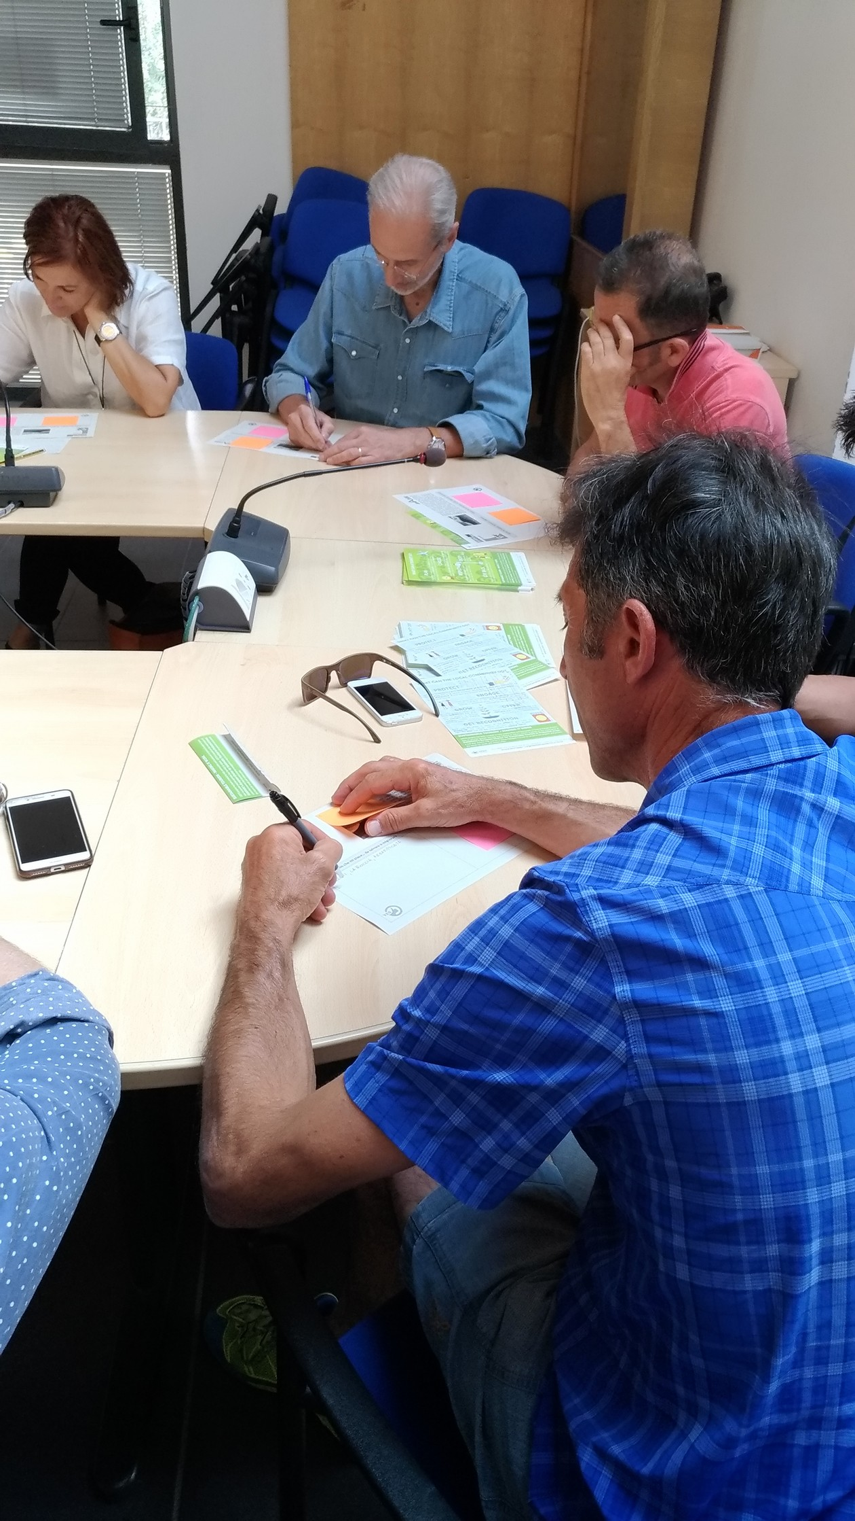
The Pilot Area of Pietra di Bismantova is subjected to high frequencies in a very short period during the year. The convenience of access by car creates parking and mobility problems. The place is seen mainly for its recreational use, not considering the natural value and the impact tourism is causing.
The main problem is the behavior of visitors which is not always adequate. There is a need to try to control these tourist flows and to distribute them a broader period (seasonal adjustment) of time and not only in the proximity of the Pietra, but also in the whole surrounding area.
The results of the workshop confirm these statements, in fact the participants have identified the landscape in its broader context as the main attraction to be saved: from the hermitage to the tranquility of the places, from hiking to climbing, from geology to biodiversity. A multidisciplinary view that characterizes and makes this area even more recognizable. Among the negative aspects, accessibility by car and the related congestion of roads and parking is the most cited, followed by the lack of a concrete connection with the country below and by the “wrong” use of the area by tourists (only recreational aspect). The keywords are therefore: accessibility, awareness and context.

Positive Aspects Negative Aspects
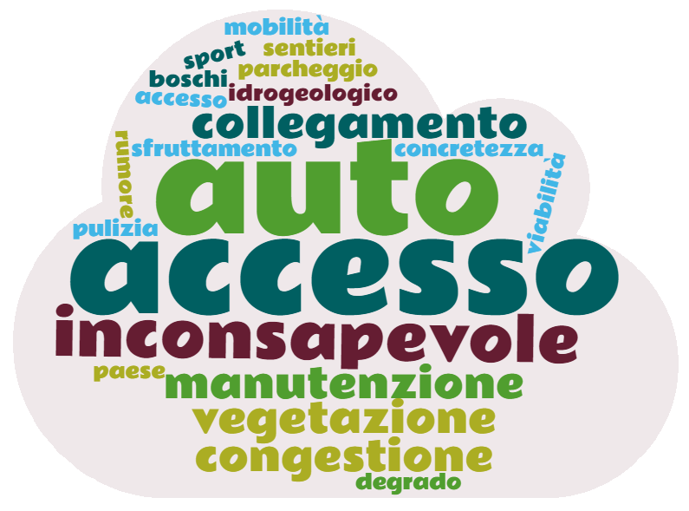
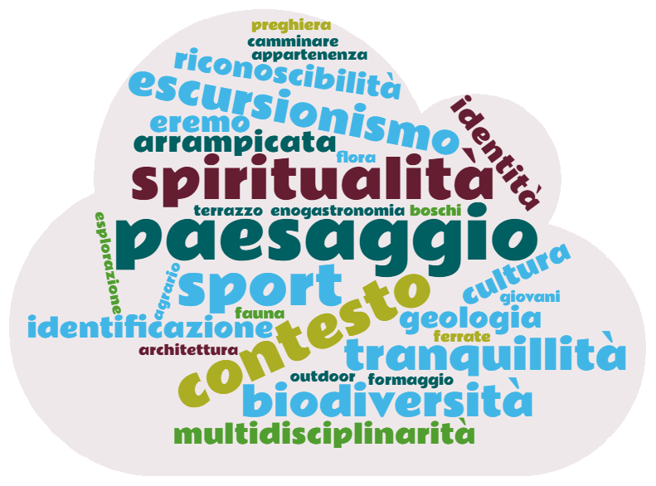

  - Pietra di Bismantova Action Plan
Title | THE STONE IS A MOLE ON THE WAY
Proposer | Appennino Tosco-Emiliano National Park
Partner | Castelnovo ne' Monti Municipality, accommodation facilities, etc.
Objective | Monitor and Manage the tourist flows that affect the area of Pietra di Bismantova, trying to distribute them over a longer period of the year and also enhancing other nearby emergencies.
Short Description | The Park commits to carry out a monitoring activity of the flows that currently affect the area of Pietra di Bismantova, placing appropriate gauges for counting and monitoring the number and type of visitors near the access roads during the period August-October 2018 and 2019. In addition to these quantitative data, a statistical survey will also be carried out, through the use of survey questionnaires, to monitor the motivations, expectations and characteristics of visitors.  The collected data will be used to monitor the effectiveness of the pilot action to create a permanent working-table for traffic flow management between the Municipality of Castelnovo ne' Monti and the Park Authority, to regulate the access with motorized vehicles, to the Stone’s parking square during the most critical days. In particular, the following activities will be implemented during the days identified:  - Extension of the car parking on the right side of the road;  - introduction of an hourly/fixed cost for access to the upper (Piazzale Dante) car parking;  - closure of the motorized passage once reached the maximum number of allowed accesses and starting of the shuttle service;  - improvement of the communication to the tourist of alternative routes (paths, thematic routes, ...) and other attractions of the area around the Stone both in the website and in the square and access roads.
Duration  Time planning | August-October 2018 – Tourists flow Monitoring;  November-December 2018 – Working table between the Park and the Municipality for the drafting of a first Traffic Management Plan;  January-February 2019 – Working group with local stakeholders to present the results of the monitoring and to discuss the draft Traffic Management Plan prepared;  March 2019 – Adoption of the Traffic Management Plan;  April-October 2019 – First application of the Traffic Management Plan;  August-October 2019 – Implementation of the monitoring activity.
Expected Results | Regulation of access to the Bismantova’s Stone area at specific times of the year through the implementation of a Traffic Management and Visitor Awareness Plan.

  - Piana di Lagdei – Workshop on the Spot
The Pilot Area of Piana di Lagdei is subjected to high frequencies, mainly during fall and summer weekends. The convenience of access by car creates parking and dust-related problems for walkers. The place is seen mainly for its recreational use, not considering the natural value.
The main problem is the behavior of visitors which is not always adequate. There is a need to try to control these tourist flows and to distribute them a broader period (seasonal adjustment) of time and to develop some activities that promote a conscious use of the territory and its environmental peculiarities.
The results of the workshop confirm these statements, in fact the participants have identified the environment - forest, bodies of water, landscape still intact - as the main attraction to be saved: Lagdei as a hub, suitable as a point of arrival for those who want to stop and enjoy the landscape and nature and as a starting point towards the paths that lead to surrounding mountains and lakes.
Among the negative aspects, accessibility by car and the related congestion of roads and parking is the most cited, followed by the dust-related problems for walkers and by the “wrong” use of the area by tourists (only recreational aspect). The keywords are therefore: accessibility and awareness.

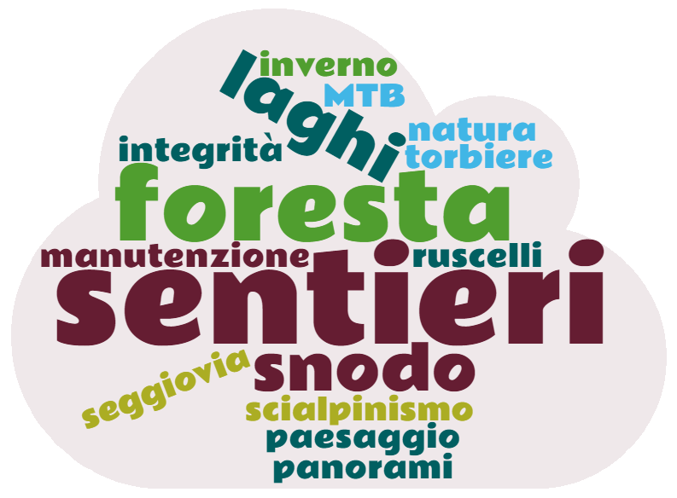
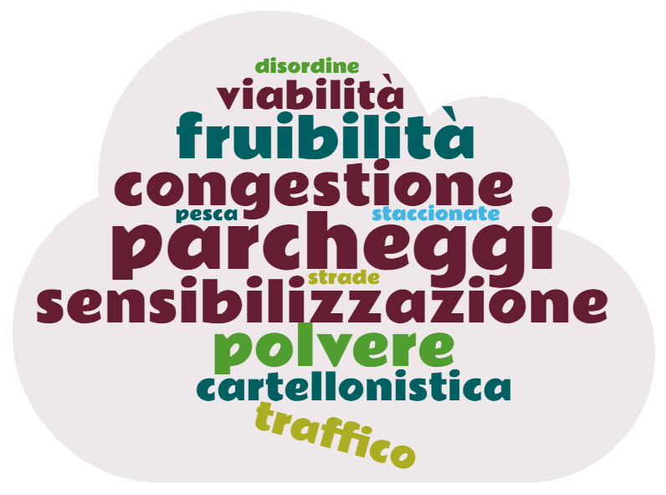
Positive Aspects Negative Aspects

Title | INSIDE NATURE - FOREST HORIZON
Proposer | Appennino Tosco-Emiliano National Park
Partner | Corniglio Municipality, accommodation facilities, Food and beverage facilities, Chairlift.
Objective | Monitor and Manage the tourist flows that affect the area of Piana Lagdei, trying to distribute them over a longer period of the year and sensitizing visitors to a more careful use of the area.
Short Description | The Park commits to carry out a monitoring activity of the flows that currently affect the area of Piana Lagdei, involving the Refuge (already Park Visitor Centre) and the other accommodation and catering facilities in the area in the administration of questionnaires specifically designed to collect data on the number, type, preferences and behaviour of visitors.  I dati raccolti serviranno a monitorare l’efficacia dell’azione pilota di realizzazione di Giornate dedicate al territorio. In particolare, durante queste giornate – individuate in accordo con le strutture del territorio – saranno realizzate le seguenti azioni:  - closure of dirt roads to vehicular traffic, allowing access only on foot or by bicycle;  - creation of connections between the area and the surrounding villages in order to expand the tourist offer during the day;  - organization of events, exhibitions, guided tours, ... related to the slow discovery of nature.
Duration  Time planning | August-October 2018 – Tourists flow Monitoring;  September-October 2018 – Realization of some thematic test days;  November 2018-February 2019 – Working group with local stakeholders to present the results of the monitoring and to discuss the days to be organised and the related activities;  March-October 2019 – Organization of the thematic days;  August-October 2019 – Implementation of the monitoring activity.
Expected Results | Realization of at least 30 thematic days with a participation of at least 200 people in the activities organized (monitoring through reservations and photos of the event).

