MONITORING Workplan

Landscape park Strunjan

D.T2.4.1 | Version 1  7 2018

- Introduction
The Monitoring Workplan for Protected Area aims at setting up a system to monitor the implemented management tools.
The Monitoring Workplan identifies monitoring locations, specific tools, time frequency, data collection/elaboration methodologies and responsible subjects.

- Description of pilot area - Belvederre terraces
Along the eastern border of Landscape Park Strunjan lie the Belvederre terraces. The area represents one of the entry points to the park. Its potential can be used as a buffer area between the urbanized, tourist area of Izola and the protected nature area. Belvederre terraces are CEETO pilot area, where management and monitoring tools will be tested in frame of CEETO project.
In this area begins the Strunjan Nature Reserve, which includes a flysch cliff with a sub Mediterranean deciduous forest, a natural coastline and a 200 m sea belt. The park supports a high diversity of plant and animal species and habitat types, exceptionally for the Slovenian Sea as well as the entire Gulf of Trieste. In addition to nature, the cultural landscape with typical agrarian elements that extend far back into the history and tradition of the area has also been preserved. Through a long history, the area of the Strunjan and Belvederre served for the purpose of producing crops, fruit and vegetables.

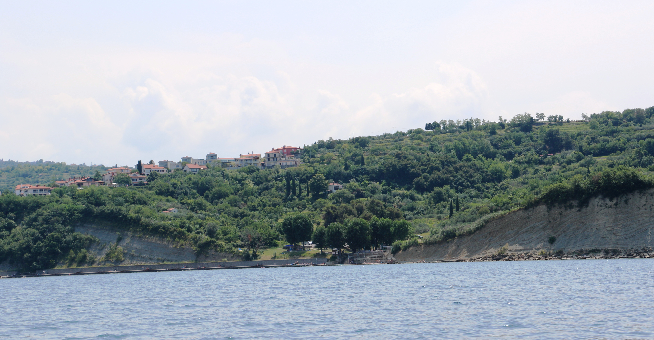
Figure 1: Belvedere terraces – pilot area

The area is hilly with quite a slope. It is arranged in the form of terraces, which are mostly private plots with olive groves. The area is rather uneven and individual parcels users are more or less maintained and restricted by various fences. The terraces extend to the sea shore, where the small area for bathing is arranged, with a pier, parking space and a bar, which is surrounded with cliffs from both sides (Figure 1).
High intensity of tourists during summer season is a significant source of pressure on natural resources. The highest concentration of tourists is reached in the summer months, i.e. in June, July, August and September. The coastal area is considered as an important element of summer tourism and not as part of the landscape with its natural values.
The increasing tendency towards spending more leisure time in and around protected area also means larger numbers of visitors in ecologically sensitive areas, with the associated intensification in land use and pressure on such areas. It was also investigated inappropriate tourist behaviour. Tourists do not comply with rules of the protected area (accessing the beach trough the different point, outside walking trails; parking outside parking area without knowing that they are in protected area). Furthermore, other important issues which protected area is facing are hotels located in the area. Construction of new hotel and recreation facilities leads to increased number of tourists. These activities can cause severe disturbance and erosion of the local ecosystem, even destruction on the long term.

- Monitoring description

Monitoring activity aims to monitor the effectiveness of education/informing the tourists about protected area and its protection regimes (Landscape park Strunjan) in the area of Belvederre terraces (Pilot Area; Figure 2). The monitoring and raising awareness action will be 2 in 1 (a leaflet/questionnaire). A questionnaire will be distributed in the pilot action area in the high season in 2018 and in 2019. A questionnaire/leaflet is divided in two parts (1. questionnaire on whether or not tourists know they are in the vicinity of the park and the satisfaction on the arrangement of the area; 2. Leaflet on Protected area Landscape park Strunjan and protection regimes; Figure 3). Tourist would deliver answered questionnaires to the bar at the beach or to the park employee and could take the leaflet with them. Also, the plan is to produce an educational animation video of the protection regimes in the park, which will also be a part of a pilot action (raising awareness).

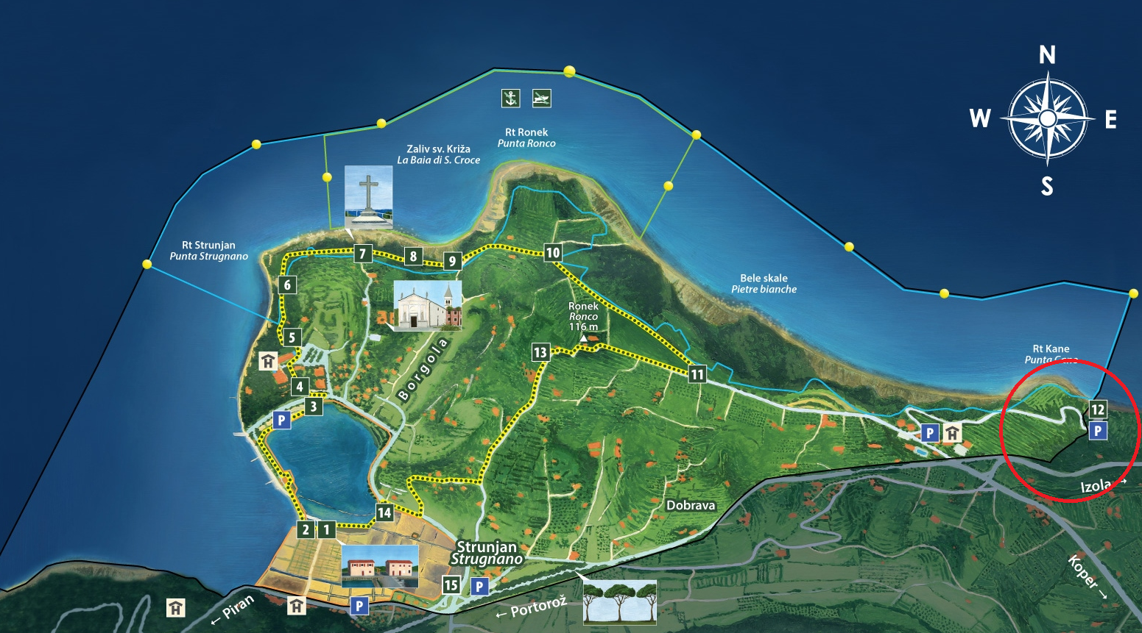
Figure 2: Pilot Area – Belvederre terraces (monitoring area)

- Questionnaire

Questionnaire/leaflet is divided in two parts:

1. Actual questionnaire on whether or not tourists know they are in the vicinity of the park and the satisfaction on the arrangement of the area;

2. Leaflet on Protected area Landscape park Strunjan and protection regimes
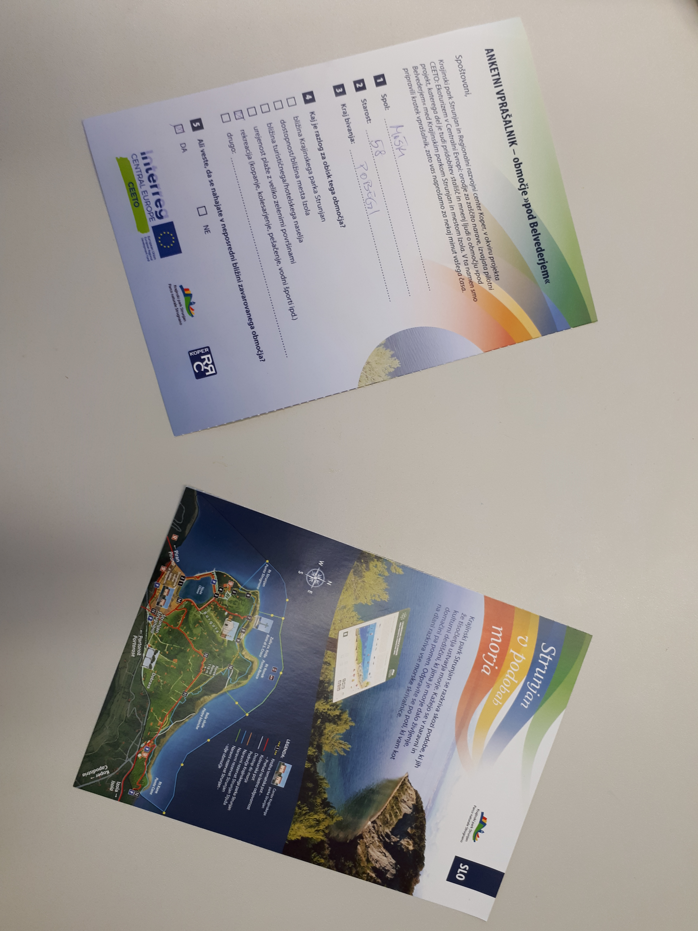
Figure 3: Answered questionnaire and removed leaflet

Questions:
- Sex:
- Age:
- Place of residence:

- What is the reason for visiting this area?
• The vicinity of Landscape Park Strunjan
• Accessibility / proximity to the city of Izola
• The vicinity of the tourist / hotel complex
• Tidiness of the beach with plenty of green areas
• Recreation (swimming, biking, hiking, water sports, etc.)
• Other:_____________

- Do you know that you are located in the immediate vicinity of the protected area?

YES NO

- Do you know what protection regimes/rules of behaviour apply in the Landscape Park Strunjan?

YES NO

Can you list some of them?_________________________________________________________

__________________________________________________________________________

- Did you visit the area in the past?

YES NO

- How did you get to the Belvedere area?
• on foot
• on a bike
• on a motorcycle
• by car
• with hotel mini bus
• other: ______________

- On a scale from 1 to 5, evaluate the tourist offer in the »Belvedere« area by circling the appropriate number for each of the listed properties.
 |  |  |  |  |  | Opinion / comment
Tidiness of the surroundings | 1 | 2 | 3 | 4 | 5
Offer of sports activities | 1 | 2 | 3 | 4 | 5
Catering offer | 1 | 2 | 3 | 4 | 5
Accessibility of tourist information | 1 | 2 | 3 | 4 | 5
Accessibility to the area | 1 | 2 | 3 | 4 | 5

- Do you miss anything in the »Belvedere« area? If yes, what? _________________________________________________________________________________________________________________________________________________________________________________________________________________________________________________________

- Monitoring workplan
 |  | 2018 |  | 2019
 | Tasks | 3/4 | 4/4 | 1/4 | 2/4 | 3/4 | 4/4
1 | Monitoring Plan
1.1 | Preparation of visitor survey
1.2 | Conduction out of visitor survey
1.3 | Data analysis
1.4 | Repetition of visitor survey
1.5 | Evaluation of results

